**Data Interpretation**

**Ques. (1-5): *The following table gives the sales of batteries manufactured by a company over the years. Study the table and answer the questions that follow*:**

**NUMBER OF DIFFERENT TYPES OF BATTERIES SOLD BY A COMPANY OVER THE YEARS (NUMBERS IN THOUSANDS)**

|  |  |  |  |  |  |  |
| --- | --- | --- | --- | --- | --- | --- |
| **Year** | **TYPES OF BATTERIES** | | | | | |
| **4AH** | **7AH** | **32AH** | **35AH** | **55AH** | **Total** |
| 1992 | 75 | 144 | 114 | 102 | 108 | 543 |
| 1993 | 90 | 126 | 102 | 84 | 126 | 528 |
| 1994 | 96 | 114 | 75 | 105 | 135 | 525 |
| 1995 | 105 | 90 | 150 | 90 | 75 | 510 |
| 1996 | 90 | 75 | 135 | 75 | 90 | 465 |
| 1997 | 105 | 60 | 165 | 45 | 120 | 495 |
| 1998 | 115 | 85 | 160 | 100 | 145 | 605 |

1. The total sales of all the seven years are the maximum for which battery?
2. 4AH (b) 7AH (c) 32AH (d) 35AH (e) 55AH
3. What is the difference in the number of 35AH batteries sold in 1993 and 1997?
4. 24000 (b) 28000 (c) 35000 (d) 39000 (e) 42000
5. The percentage of 4Ah batteries sold to the total number of batteries sold was maximum in the year:
6. 1994 (b) 1995 (c) 1996 (d) 1997 (e) 1998
7. In the case of which battery there was a continuous decrease in sales from 1992 to 1997?
8. 4AH (b) 7AH (c) 32AH (d) 35AH (e) 55AH
9. What was the approximate percentage increase in the sales of 55AH batteries in 1998 compared to that in 1992?
10. 25% (b) 31% (c) 33% (d) 34% (e) 37%

**Ques. (6-10): Study the following table carefully and answer these questions**:

**NUMBER OF CANDIDATES APPEARED AND QUALIFIED IN A COMPETITIVE EXAMINATION FROM DIFFERENT STATES OVER THE YEARS**

|  |  |  |  |  |  |  |  |  |  |  |
| --- | --- | --- | --- | --- | --- | --- | --- | --- | --- | --- |
| **Year State** | **1997** | | **1998** | | **1999** | | **2000** | | **2001** | |
| **App.** | **Qual.** | **App.** | **Qual.** | **App.** | **Qual.** | **App.** | **Qual.** | **App.** | **Qual.** |
| M | 5200 | 720 | 8500 | 980 | 7400 | 850 | 6800 | 775 | 9500 | 1125 |
| N | 7500 | 840 | 9200 | 1050 | 8450 | 920 | 9200 | 980 | 8800 | 1020 |
| P | 6400 | 780 | 8800 | 1020 | 7800 | 890 | 8750 | 1010 | 9750 | 1250 |
| Q | 8100 | 950 | 9500 | 1240 | 8700 | 980 | 9700 | 1200 | 8950 | 995 |
| R | 7800 | 870 | 7600 | 940 | 9800 | 1350 | 7600 | 945 | 7990 | 885 |

1. Combining the states P and Q together in 1998, what is the percentage of the candidates qualified to that of the candidates appeared?
2. 10.87% (b) 11.49% (c) 12.35% (d) 12.54% (e) 13.05%
3. The percentage of the total number of qualified candidates to the total number of appeared candidates among all the five states in 1999 is:
4. 11.49% (b) 11.84% (c) 12.21% (d) 12.57% (e) 12.73%
5. What is the percentage of candidates qualified from State N for all the years together, over the candidates appeared from State N during all the years together?
6. 12.36% (b) 12.16% (c) 11.47% (d) 11.15% (e) None of these
7. What is the average of candidates who appeared from State Q during the given year?
8. 8700 (b) 8760 (c) 8810 (d) 8920 (e) 8990
9. In which of the given years the number of candidates appeared from State P has maximum percentage of qualified candidates?
10. 1997 (b) 1998 (c) 1999 (d) 2000 (e) 2001
11. Total number of candidates qualified from all the states together in 1997 is approximately what percentage of the total number of candidates qualified from all the states together in 1998?
12. 72% (b) 77% (c) 80% (d) 83% (e) 86%

**Ques. (11-15): The following table gives the percentage of marks obtained by seven students in six different subjects in an examination. Study the table and answer the questions based on it. The numbers in the brackets give the maximum marks in each subject.**

|  |  |  |  |  |  |  |
| --- | --- | --- | --- | --- | --- | --- |
| **Subjects (Max. Marks / Student** | **Maths**  **(150)** | **Chemistry**  **(130)** | **Physics**  **(120)** | **Geography**  **(100)** | **History**  **(60)** | **Computer Science**  **(40)** |
| Ayush | 90 | 50 | 90 | 60 | 70 | 80 |
| Aman | 100 | 80 | 80 | 40 | 80 | 70 |
| Sajal | 90 | 60 | 70 | 70 | 90 | 70 |
| Rohit | 80 | 65 | 80 | 80 | 60 | 60 |
| Muskan | 80 | 65 | 85 | 95 | 50 | 90 |
| Tanvi | 70 | 75 | 65 | 85 | 40 | 60 |
| Tarun | 65 | 35 | 50 | 77 | 80 | 80 |

1. What was the aggregate of marks obtained by Sajal in all the six subjects?
2. 409 (b) 419 (c) 429 (d) 439 (e) 449
3. What is the overall percentage of Tarun?
4. 52.5% (b) 55% (c) 60% (d) 63% (e) 64.5%
5. What are the average marks obtained by all the seven students in Physics? (rounded off to two digits after decimal)

(a) 77.26 (b) 89.14 (c) 91.37 (d) 96.11 (e) 103.21

1. The number of students who obtained 60% and above marks in all the subjects is:
2. 1 (b) 2 (c) 3 (d) None (e) None of these
3. In which subject is the overall percentage the best?
4. History (b) Maths (c) Physics (d) Chemistry (e) Geography

**Ques. (16-20): Study the following table carefully and answer the questions given below:**

**CLASSIFICATION OF 100 STUDENTS BASED ON THE MARKS OBTAINED BY THEM IN PHYSICS AND CHEMISTRY IN AN EXAMINIATION**

|  |  |  |  |  |  |
| --- | --- | --- | --- | --- | --- |
| **Marks out of 50 / Subject** | **40 and above** | **30 and above** | **20 and above** | **10 and above** | **0 and above** |
| Physics | 9 | 32 | 80 | 92 | 100 |
| Chemistry | 4 | 21 | 66 | 81 | 100 |
| (Aggregate) Average | 7 | 27 | 73 | 87 | 100 |

1. The number of students scoring less than 40% marks in aggregate is:
2. 13 (b) 19 (c) 20 (d) 27 (e) 34
3. If at least 60% marks in physics are required for pursuing higher studies in Physics, how many students will be eligible to purse higher studies in Physics?
4. 27 (b) 32 (c) 34 (d) 41 (e) 68
5. What is the difference between the number of students passed with 30 as cut-off marks in Chemistry and those passed with 30 as cut-off in aggregate?
6. 3 (b) 4 (c) 5 (d) 6 (e) 7
7. The percentage of the number of students getting at least 60% marks in Chemistry over those getting at least 40% marks in aggregate, is approximately:
8. 21% (b) 27% (c) 29% (d) 31% (e) 34%
9. If it is known that at least 23 students were eligible for a Symposium on Chemistry, the minimum qualifying marks in Chemistry for eligibility to Symposium would lie in the range:
10. 40-50 (b) 30-40 (c) 20-30 (d) Below 20 (e) Cannot be determined

**Ques. (21-24): The following table gives the percentage distribution of population of five states, P, Q, R, S and T on the basis of poverty line and also on the basis of sex. Study the table and answer the questions based on it.**

|  |  |  |  |
| --- | --- | --- | --- |
| **State** | **Percentage of**  **Population below**  **Poverty line** | **Proportion on Males and Females** | |
| **Below Poverty Line** | **Above Poverty Line** |
| **M : F** | **M : F** |
| P | 35 | 5 : 6 | 6 : 7 |
| Q | 25 | 3 : 5 | 4 : 5 |
| R | 24 | 1 : 2 | 2 : 3 |
| S | 19 | 3 : 2 | 4 : 3 |
| T | 15 | 5 : 3 | 3 : 2 |

1. What will be the number of females above poverty line in the state S if it is known that the population of State S is 7 million?

(a) 3 million (b) 2.43 million (c) 1.33 million (d) 5.7 million (e) 1.61 million

22. If the male population above poverty line for State R is 1.9 million, then the total population of State R is:

(a) 4.5 million (b) 4.85 million (c) 5.35 million (d) 6.25 million (e) 7.6 million

23. What will be the male population above poverty line for State P if the female population below poverty line for

State P is 2.1 million?

(a) 2.1 million (b) 2.3 million (c) 2.7 million (d) 3.3 million (e) 3.4 million

24. If the population of males below poverty line for State Q is 2.4 million and that for State T is 6 million, then the

total populations of states Q and T are in the ratio:

(a) 1 : 3 (b) 2 : 5 (c) 3 : 7 (d) 4 : 9 (e) 5 : 12

**Ques. (25-29): The bar graph given below shows the sales of books (in thousand number) from six branches of a publishing company during two consecutive years 2000 and 2001.**

**Sales of Books (in thousand numbers) from Six Branches - B1, B2, B3, B4, B5 and B6 of a publishing Company in 2000 and 2001.**

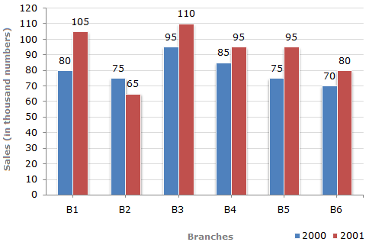

25. What is the ratio of the total sales of branch B2 for both years to the total sales of branch B4 for both years?

A.2:3 B.3:5 C.4:5 **D.7:9**

26. Total sales of branch B6 for both the years is what percent of the total sales of branches B3 for both the years?

A.68.54% B. 71.11% **C.73.17%** D.75.55%

27. What percent of the average sales of branches B1, B2 and B3 in 2001 is the average sales of branches B1, B3 and B6 in 2000?

A.75% B.77.5% C.82.5% **D.87.5%**

28. What is the average sale of all the branches (in thousand numbers) for the year 2000?

A.73 **B.80** C.83 D.88

29. Total sales of branches B1, B3 and B5 together for both the years (in thousand numbers) is?

A.250 B.310 C.435 **D.560**

**Ques. (30-32):** The following pie-chart shows the percentage distribution of the expenditure incurred in publishing a book. Study the pie-chart and the answer the questions based on it.

**Various Expenditures (in percentage) Incurred in Publishing a Book**

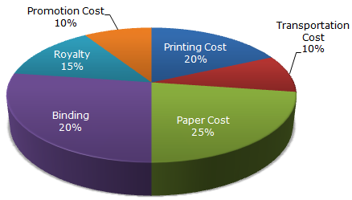

30.  If for a certain quantity of books, the publisher has to pay Rs. 30,600 as printing cost, then what will be amount of royalty to be paid for these books?

A.Rs. 19,450 B.Rs. 21,200 **C. Rs. 22,950** D.Rs. 26,150

31. What is the central angle of the sector corresponding to the expenditure incurred on Royalty?

A.15º B.24º **C.54º** D.48º

32.  If 5500 copies are published and the transportation cost on them amounts to Rs. 82500 if cost price of one copy is 135, then what should be the selling price of the book so that the publisher can earn a profit of 25%?

**A.Rs. 187.50** B.Rs. 191.50 C.Rs. 175 D.Rs. 180

**Ques. (33-35):** Study the following line graph and answer the questions.

**Exports from Three Companies Over the Years (in Rs. cr)**

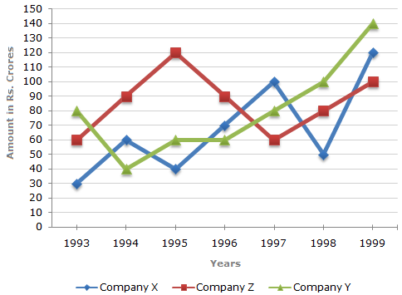

33. For which of the following pairs of years the total exports from the three Companies together are equal?

A.1995 and 1998 B.1996 and 1998 C.1997 and 1998 **D.1995 and 1996**

34. In which year was the difference between the exports from Companies X and Y the minimum?

A.1994 B.1995  **C.1996** D.1997

35. What was the difference between the average exports of the three Companies in 1993 and the average exports in 1998?

A.Rs. 15.33 cr. B.Rs. 18.67 cr. **C.Rs. 20 cr.** D.Rs 16.17 cr.